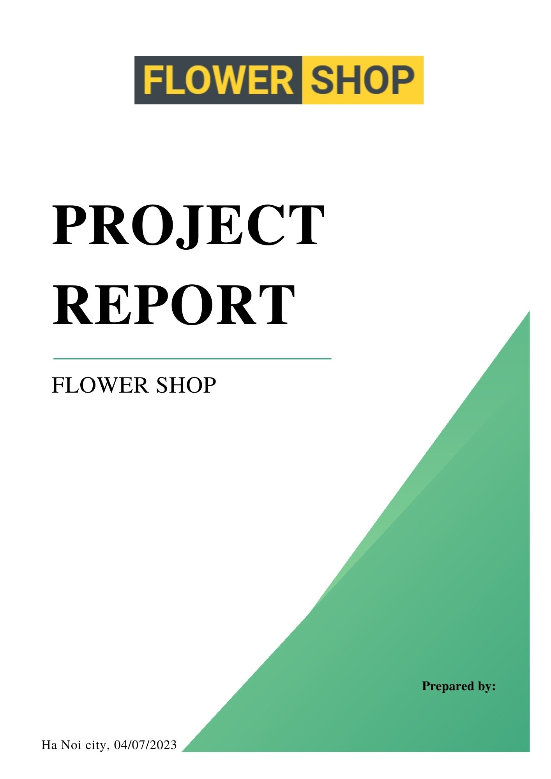

**MENU:**

**I. Introduction ............................................................................................................................**

**II. Programming Software .........................................................................................................**

**III. The Detail Of Manage System .............................................................................................**

**IV. The operation of this online flower-selling website ............................................................**

**V. Conclusion ...............................................................................................................................**

FLOWERSHOP : The convenient online flower shop

**I/Introduction:**

Welcome to our online flower shop, where convenience meets beauty! At our website, you'll find a wide selection of stunning floral arrangements, all available at your fingertips.

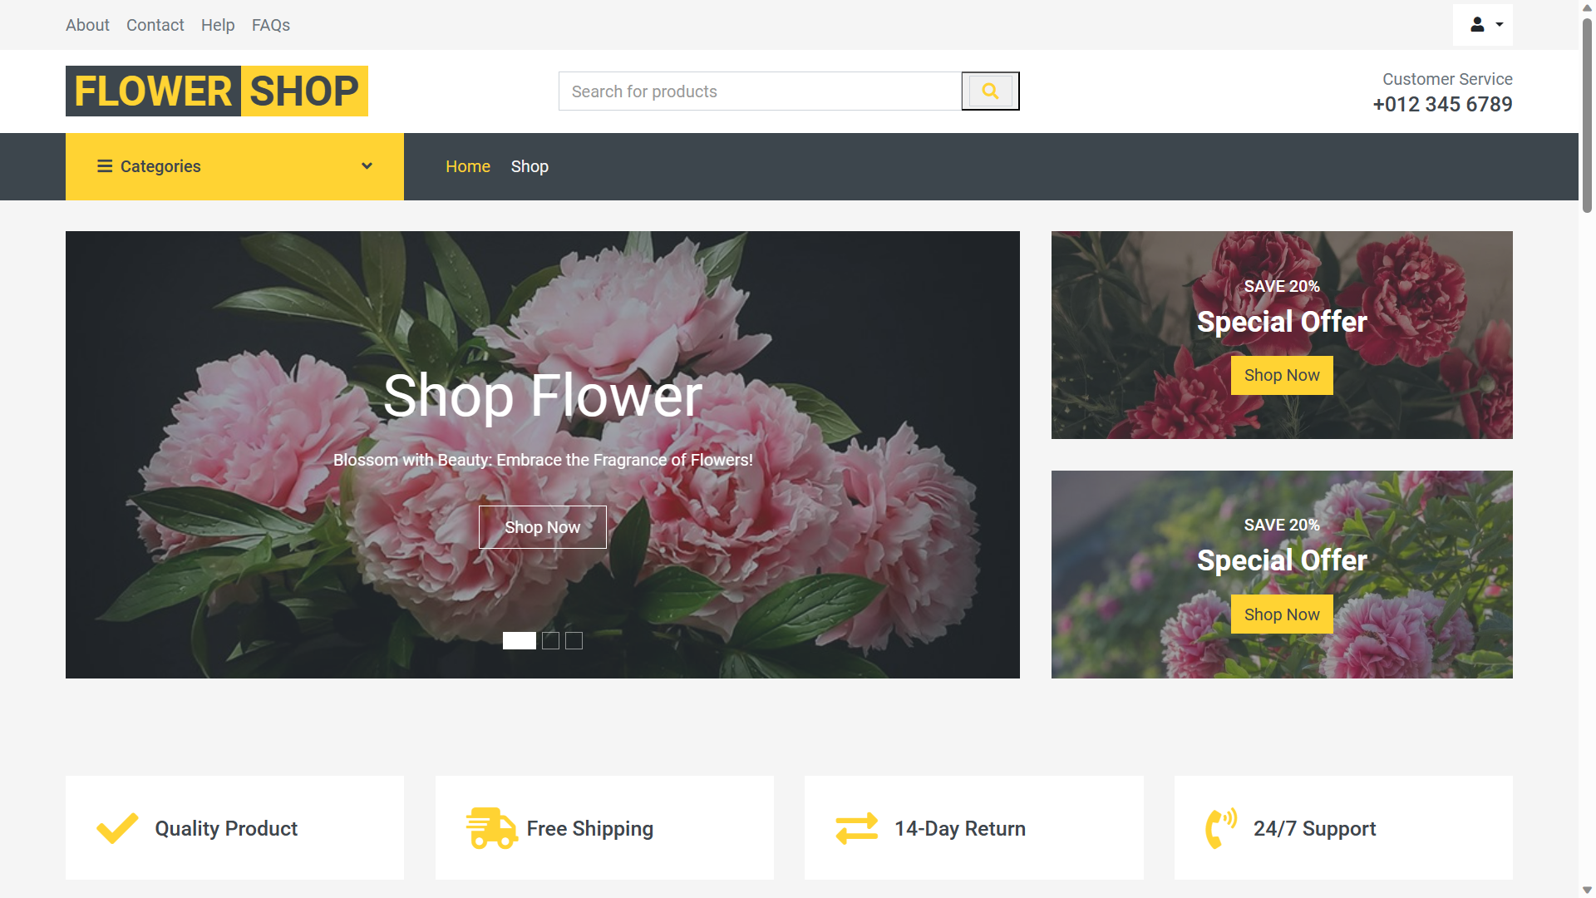

Shopping for flowers has never been easier. With just a few clicks, you can explore our virtual flower boutique and discover a world of exquisite blooms. Whether you're celebrating a special occasion, expressing your love and gratitude, or simply brightening someone's day, we have the perfect arrangement for every moment.

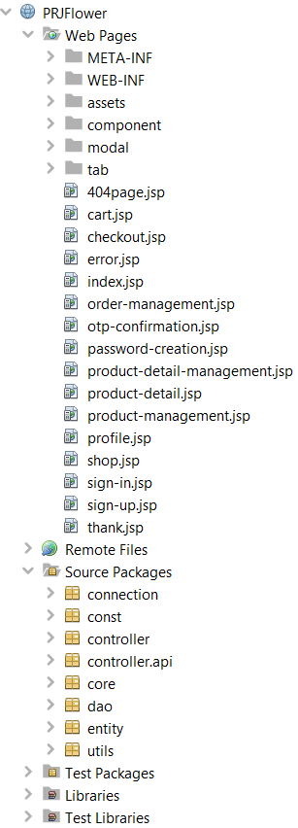**II/Programming Software:**

In this project, we utilized the following programming tools

to interact with the management system:

1. SQL

2. Java

3. HTML

4. CSS

5. JS

6. API

**III/The detail of management system:**

• SQL SERVER: To create a flowchart for the administration of shoe models, sizes, brands, quantities, income sources, orders,...

Create query instructions to search for items, alter order status, determine revenue sources, and sort products, among other things.

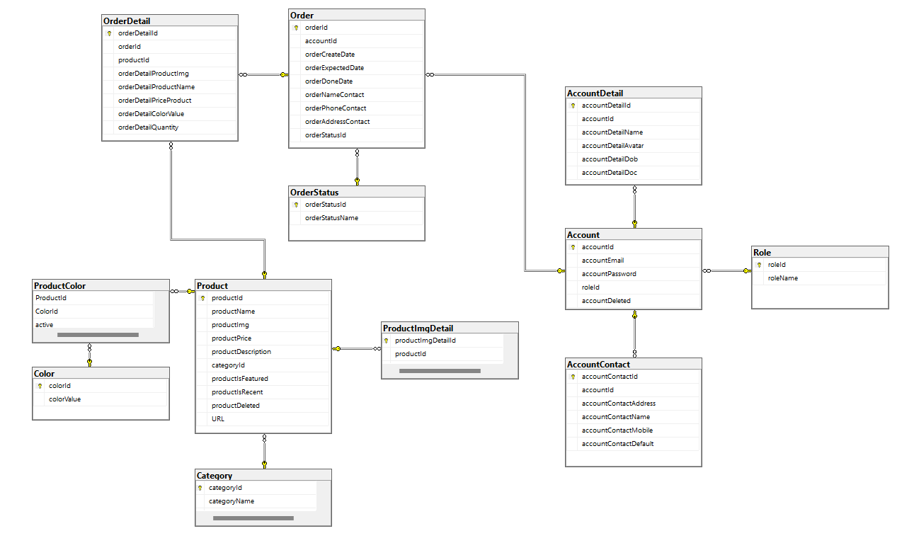

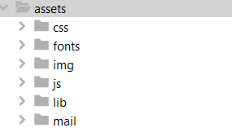

* JAVA:
* At Folder assets we have files to serve web design such as css, img, js, ...

- JSP scripts to show information received from the servlet's attributes.

- The duty of connecting java to the database in SQL is received in the connection folder including the java file.

- A class in the entity folder corresponds to each table in the database.

- Folders contain code files that handle data from the database by performing queries and returning objects or object lists.

- The Servlet file's function is to carry out the instructions included in the knife folder and provide information to the JSP file.

-Servlet files to handle incoming data for the administration page are located in the controller folder.

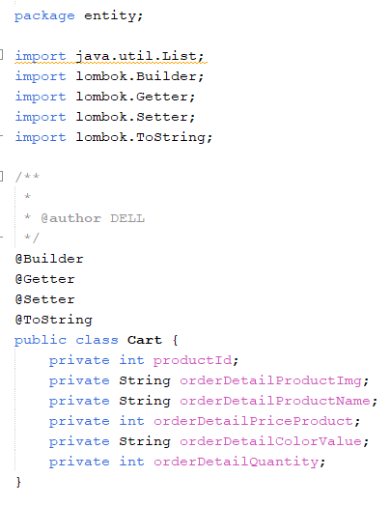

- The class "Cart" is one more in the package entity. The items in the cart will be defined and stored as a session by this class.

- Here, the project makes use of the Lombok library to streamline the code and enable flexible editing of the object's properties.

**IV/ The operation of this online flower-selling website:**

**1)Guest:**

When accessing my website, similar to other web platforms, customers can still access the store and view products without needing to log in to an account.

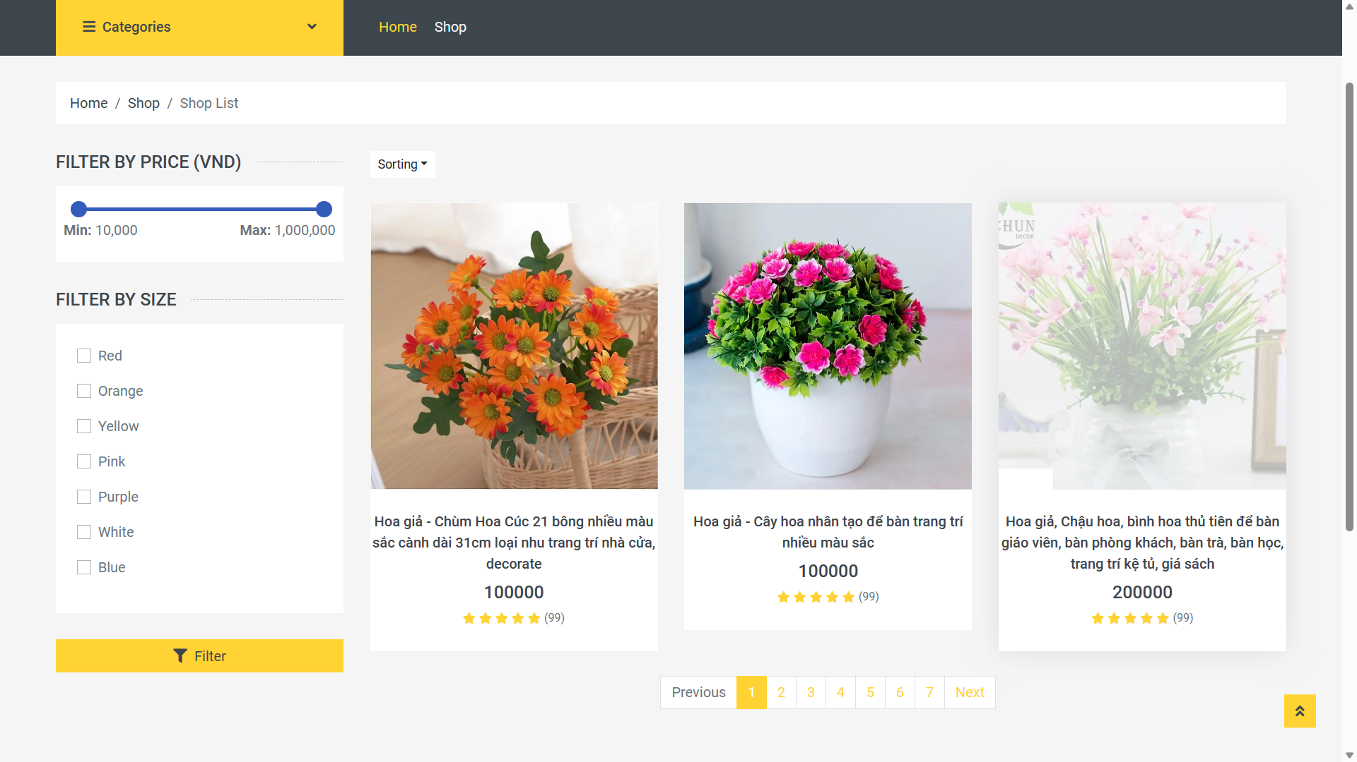

However, to purchase a specific product, you would need to create a login account where we can gather essential information from you, such as your phone number, shipping address, and customer name.

Below are the images depicting the scenario when you access a product to add it to the cart without being logged in and when you are logged in:

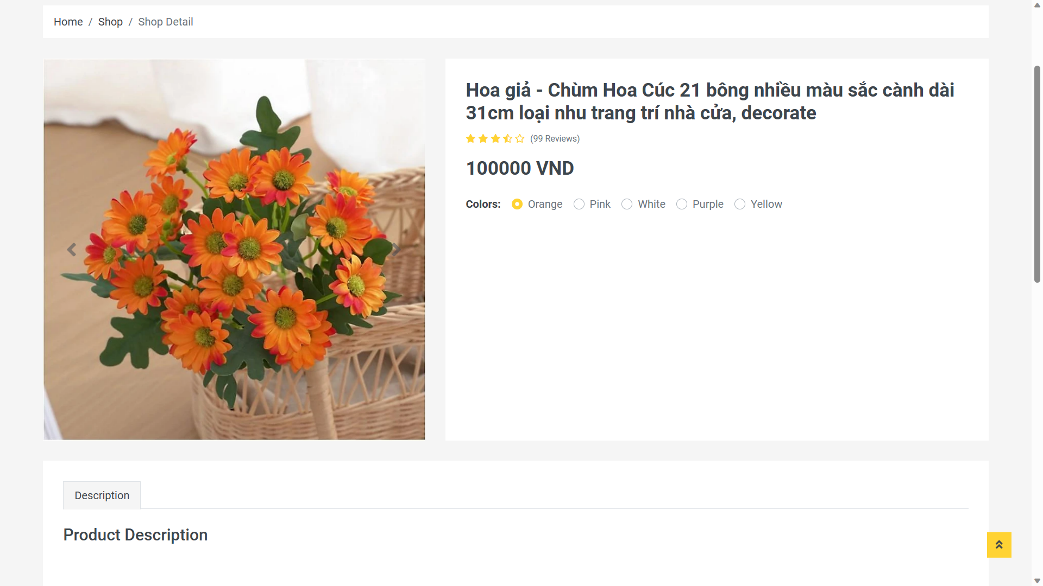 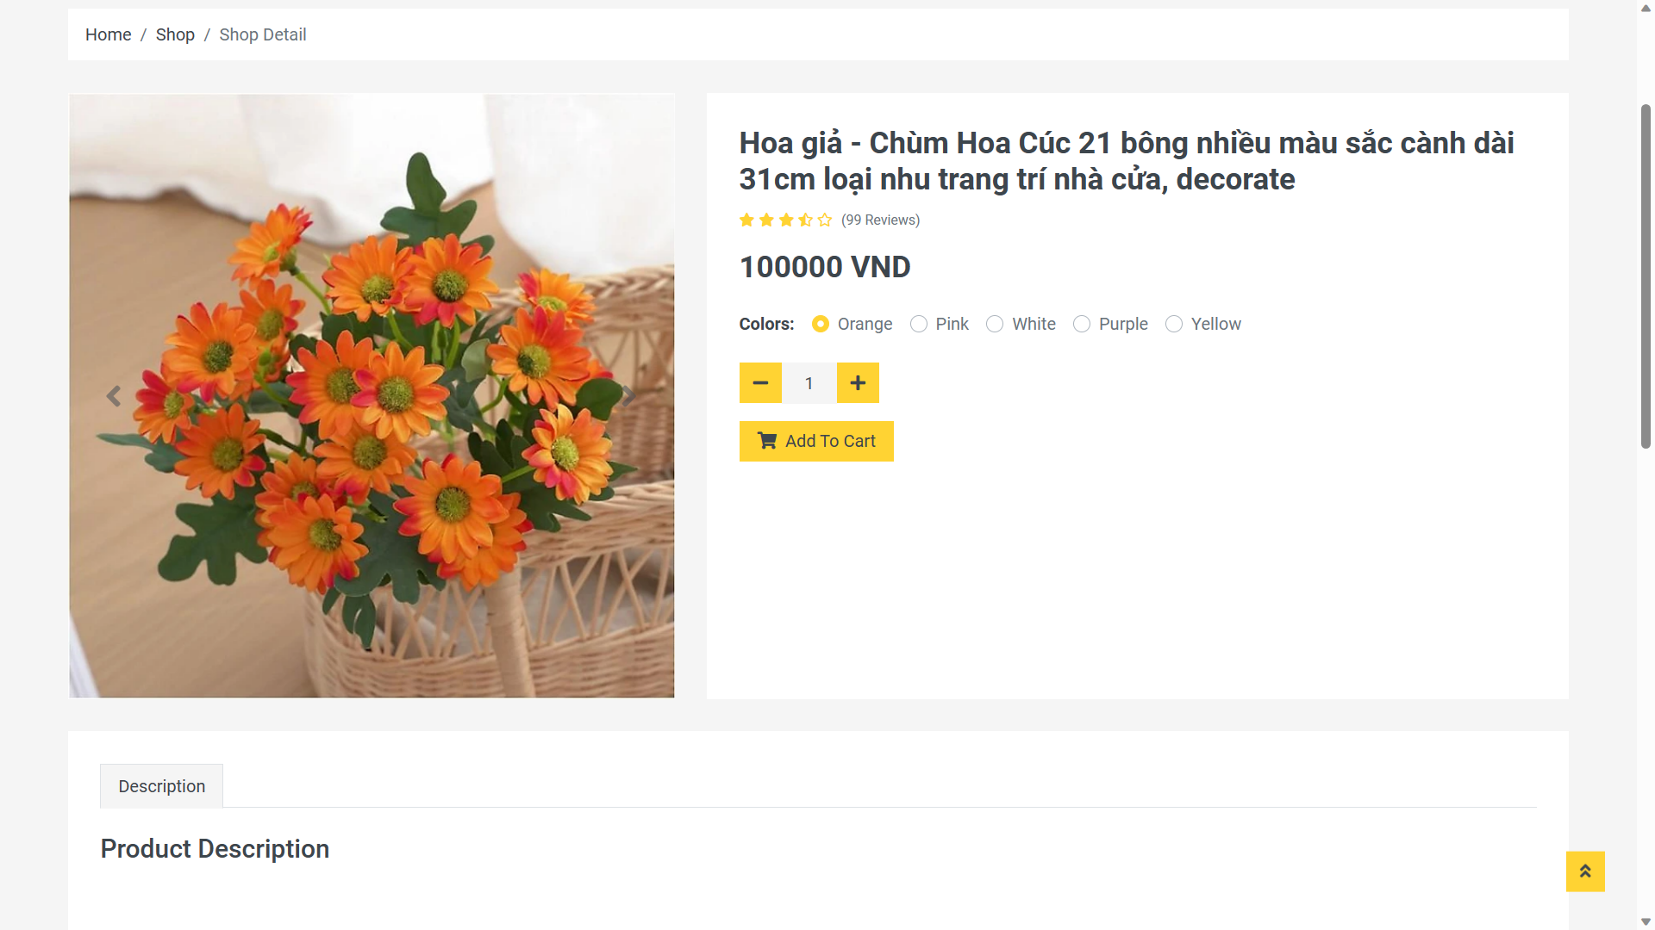

The difference between the two images is that when you log in to your account, the cart functionality is enabled, allowing you to add products to the cart for checkout. On the other hand, when not logged in, the cart is not set up, and you cannot add your favorite products to the cart.

After selecting the desired product, including color and quantity, you need to access the cart to complete the transaction. Here is the interface of our store's shopping cart:

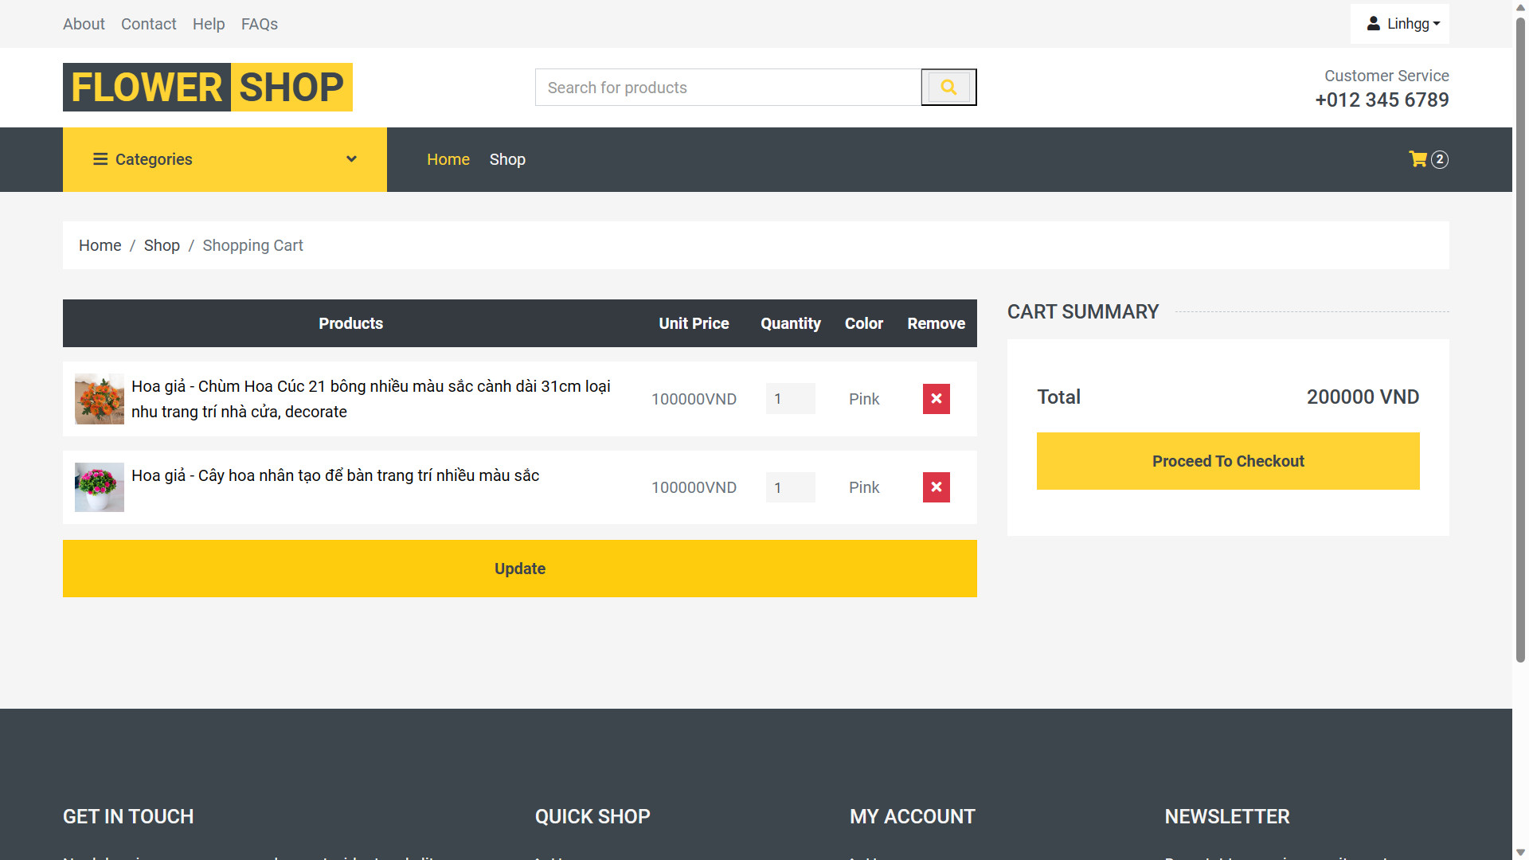

In the shopping cart, you can modify the quantity, color, or remove products that the customer wants to reconsider before proceeding to payment. After customers have reviewed their shopping cart and confirmed its completeness, they can click on the checkout button.

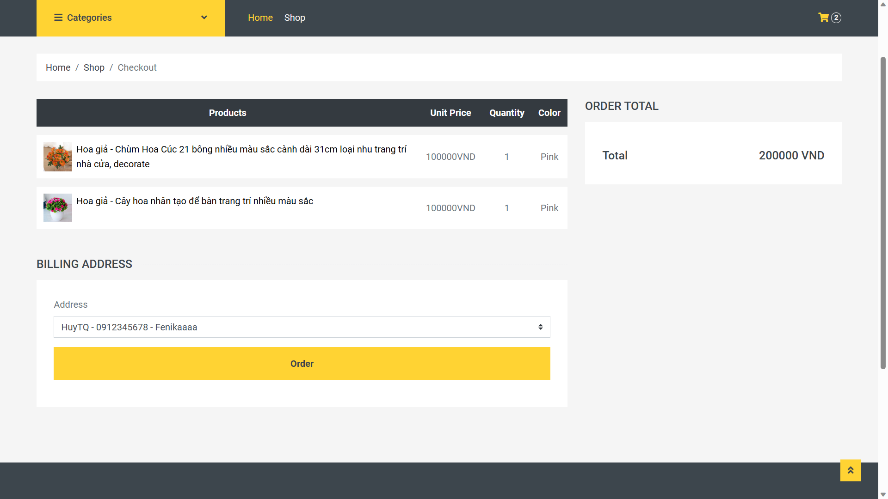

After clicking the checkout button, you will be prompted to choose a shipping address for us to deliver the order to. Each account will have a fixed address associated with it when you add an address to your profile. Once you have successfully selected the shipping address, you will proceed by clicking the "order" button.

Here is the interface after you have successfully placed the order. You will be redirected back to the home page of the store when you click the "back to home" button. When a customer places an order, the order will be pushed to the admin's account for them to confirm.

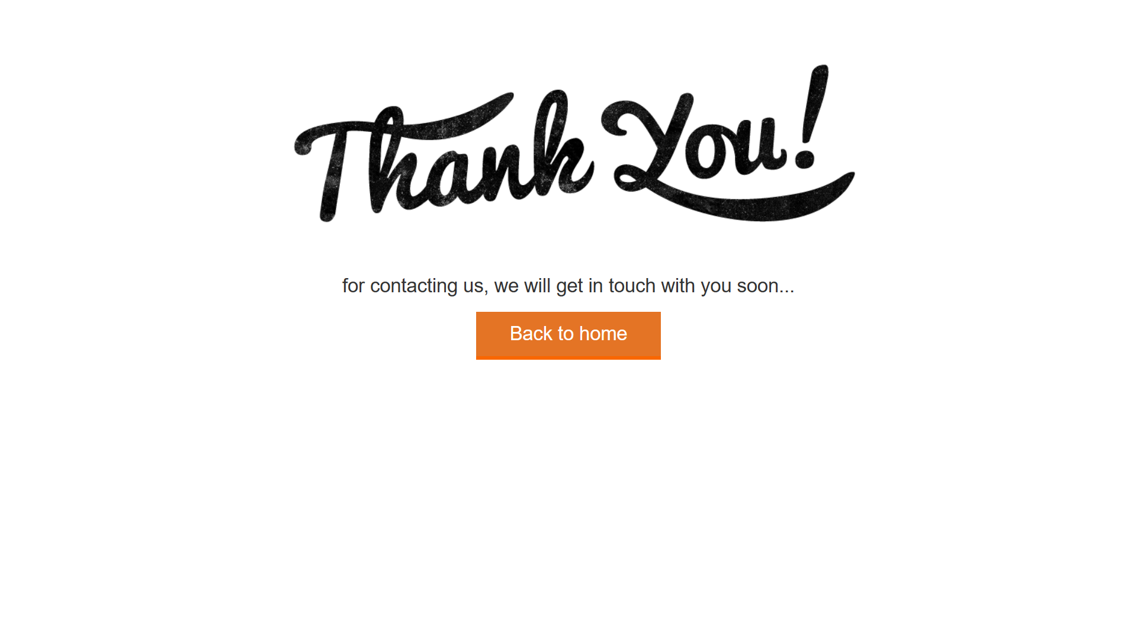

**2).Admin:**

In our store, there are two distinct user roles: customers and administrators.

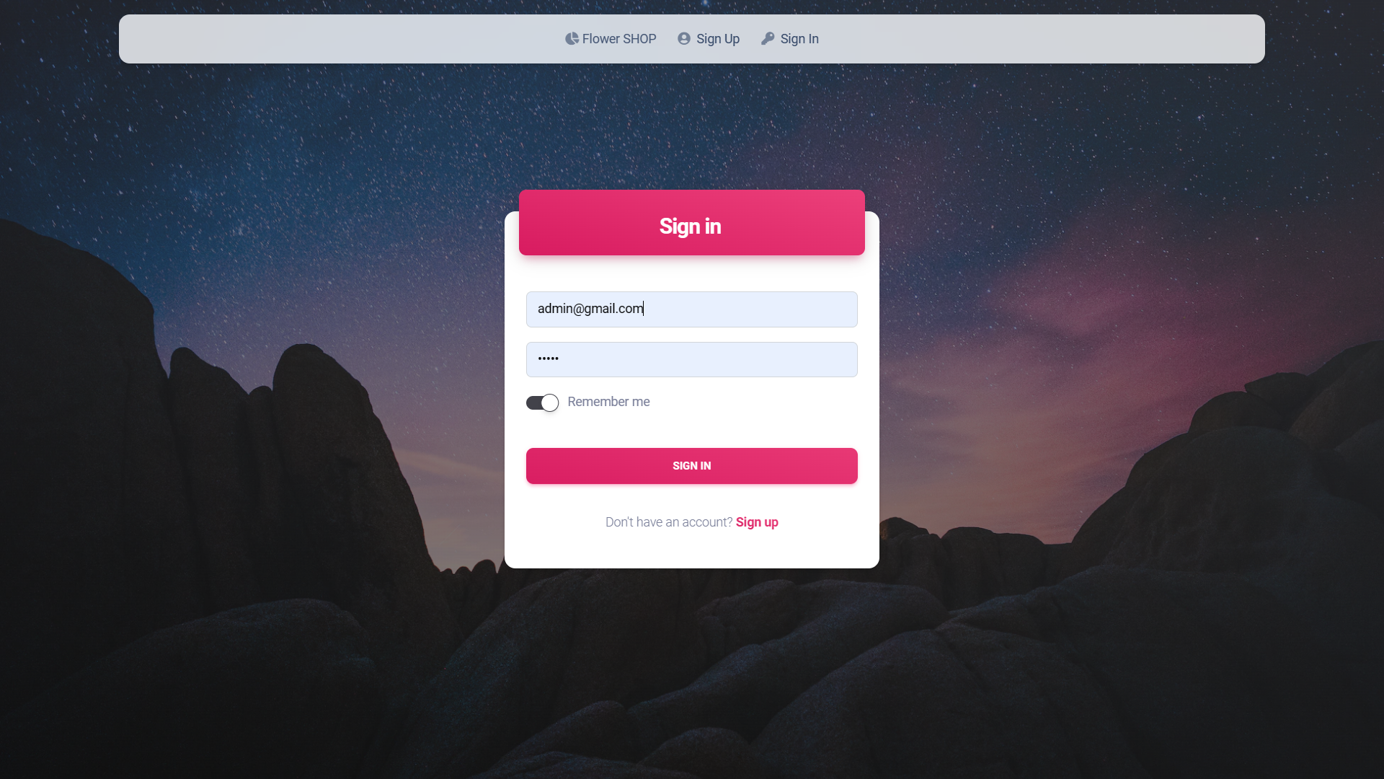

When logging in with an admin account, the administrator will have access to the dedicated management page of the store, as follows.

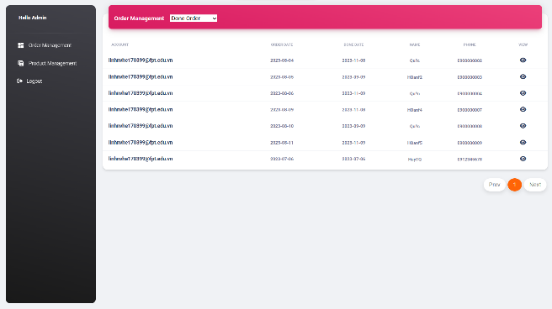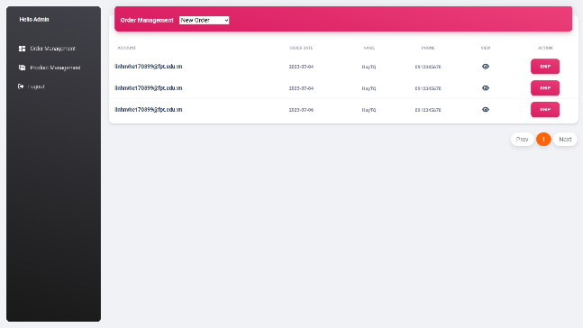

With an admin account, they will be responsible for approving customer orders and carrying out the shipping process (New order,delivering order,done order).Additionally, admins can manage the product inventory by adding or removing items in the product management section, ensuring that customers can see the updated product offerings in the store.

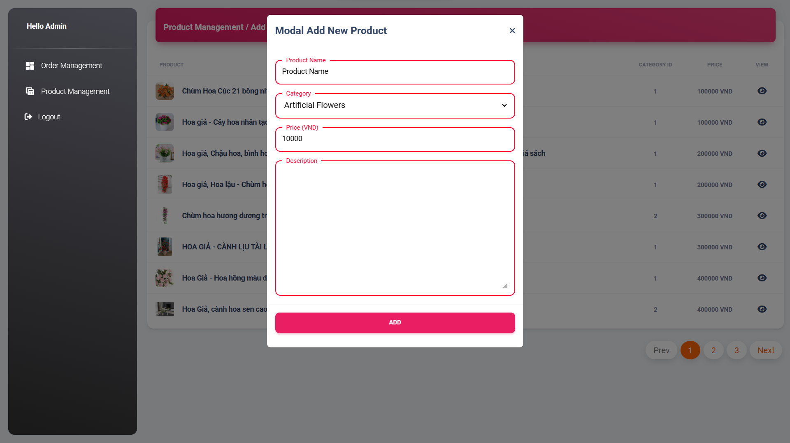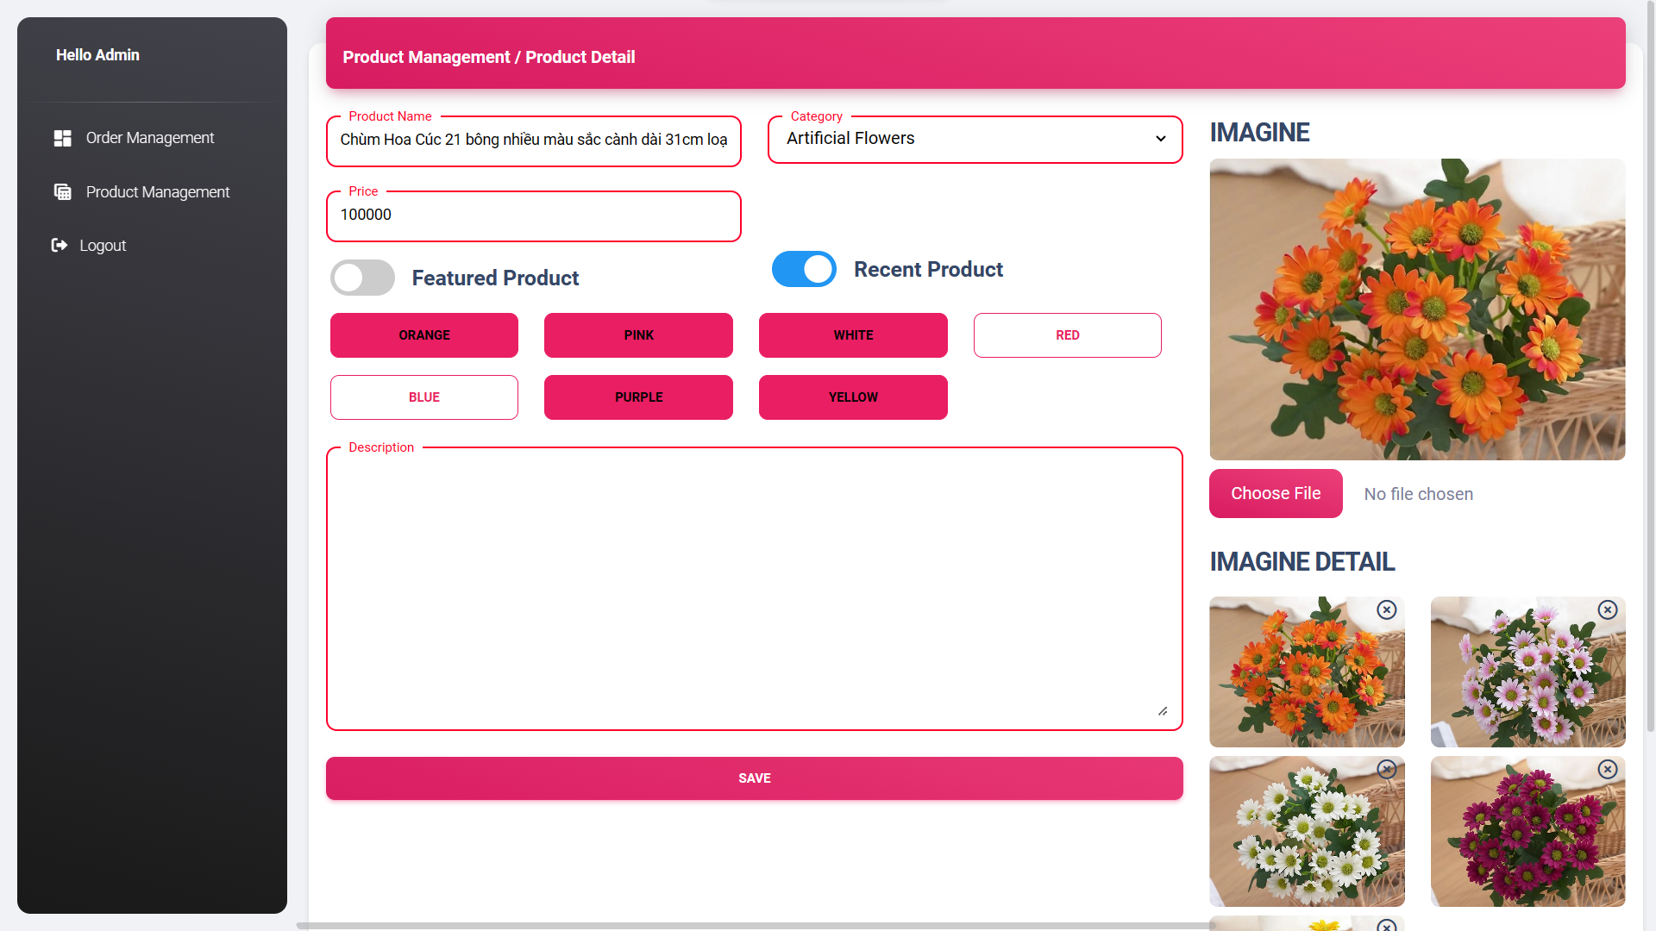

Furthermore, like other websites, this is the profile interface of an account when you register: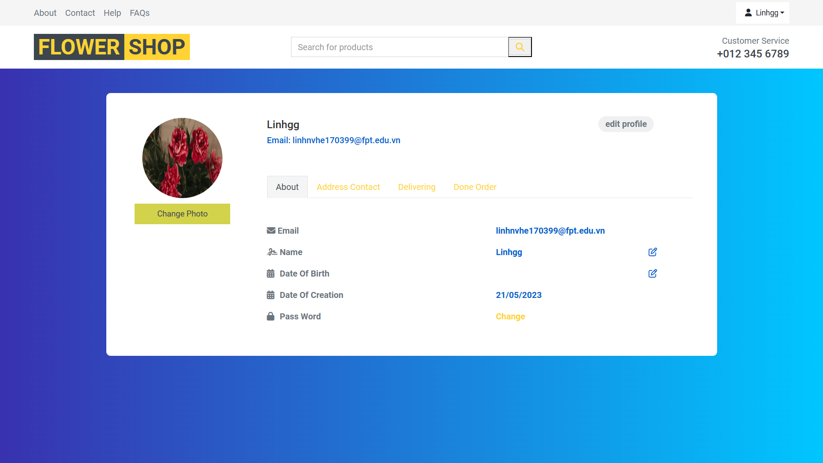

You can change your password, update your phone number, date of birth, and add a shipping address. You can also designate a specific address as your default address, as mentioned earlier.

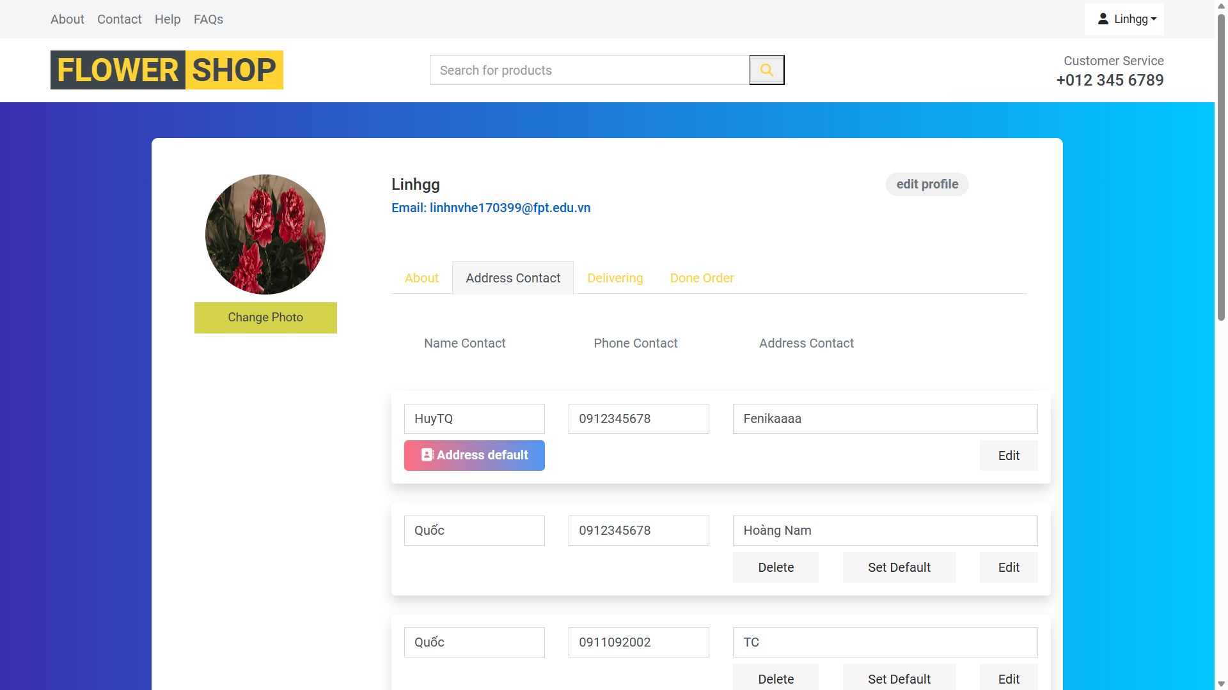

Additionally, you can check the status of your orders in two sections: "delivering" and "done order.

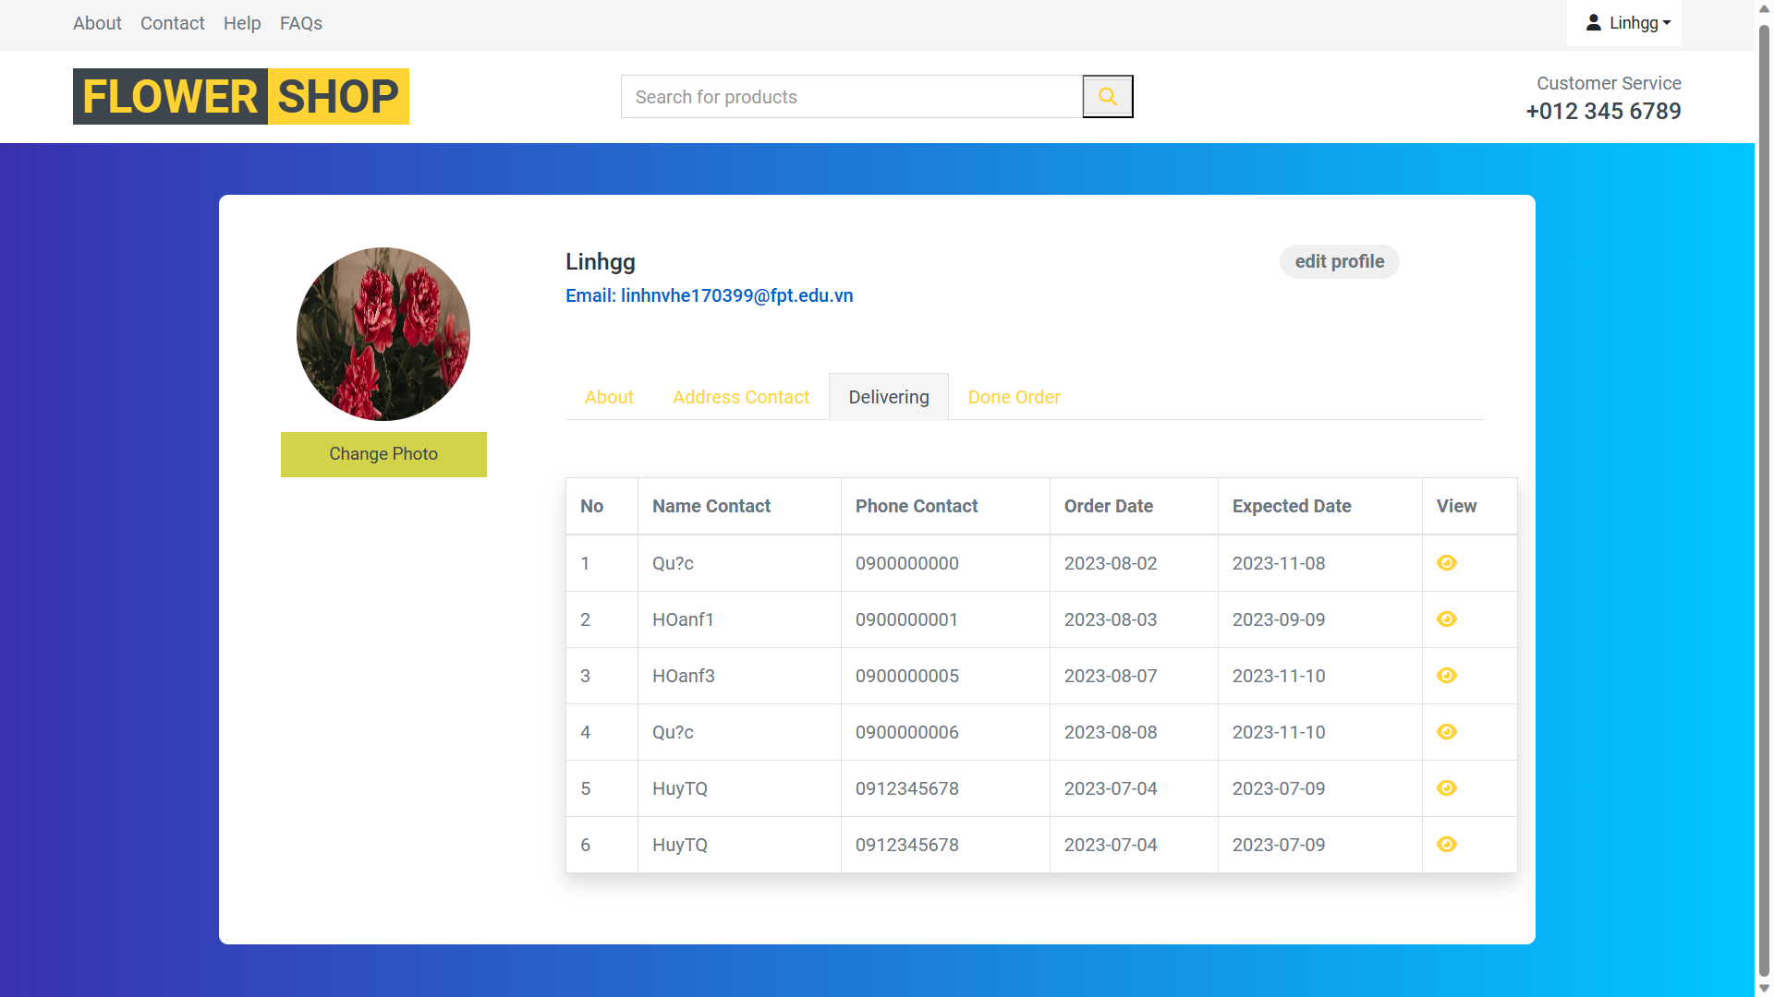

**V/Conclusion:**

Our online flower selling website has achieved significant milestones in providing a high-quality platform for purchasing flowers online. With a user-friendly and intuitive interface, we have created a convenient and engaging shopping experience for our customers.

Our website offers a diverse collection of fresh flowers, providing ample choices for our customers. We have set a goal to deliver fresh and high-quality flower arrangements, and through our professional flower care process, we ensure that each bouquet is delivered to our customers in the freshest condition.